Candescent SAML Feature Toolkit
User Guide
v1.0

Version History
Version | Date | Author(s) | Reviewed By | Remarks
0.1 | 04-Dec-2025 | Asiya Khatib | Pinkar Kumari / Saurabh Prasad | Initial draft version
0.2 | 11-Dec-2025 | Asiya Khatib | Premal Shrivastava / Abhishek Anand | Updates after review by Candescent PO, QA
1.0 | 15-Dec-2025 | Vandita Verma | Premal Shrivastava / Abhishek Anand / Saurabh Prasad | New chapter added for Validator & Publisher feature

Candescent SAML Feature Toolkit 1
Version History 2
1. Introduction 3
2. How to get SAML Toolkit? 3
3. Setting Up the SAML Toolkit 3
3.1 Docker Based Setup 4
Prerequisites 4
Setup Steps 4
Installation steps for Shell environment (Mac/Linux) 4
Installation steps for PowerShell environment (Windows) 8
3.2 Local Machine Native Setup 14
Prerequisites 14
Setup Steps 14
4. SAML Toolkit overview 17
4.1 Frontend 18
4.2 Backend 18
5. Executing the SAML Toolkit 18
Step 1 — User Opens the sample Web Application 19
Step 2 — Enter Values for following fields 19
Note: 21
What the frontend does 21
Note: 23
What the backend does 23
6. SAML Endpoints and Parameters 23
6.1 SAML login 24
Purpose 24
Example Request 24
7. Validator and Publisher 26

1. Introduction
The SAML Feature Toolkit allows developers from Vendor/FI organizations to test and validate a complete simulated SAML Single Sign-On (SSO) flow, compatible with Candescent production environment, in a local development environment. This Toolkit acts as a simulator to replicate the key functionalities of a SAML, such as generating SAML assertions. Thus, it allows developers to verify during development, that their application’s SAML integration works as expected, and is compatible with the Candescent production environment.
The toolkit allows FI/Vendor developers to:
- Quickly set up backend & frontend applications.
- Integrate their application with the Toolkit sample application and execute the SAML flow.
- Generate and validate sample XML Assertion and verify the user's information.

2. How to get SAML Toolkit?
Please visit the JFrog Artifactory to download the SAML Toolkit - [AA1] : JFrog Artifactory
If you do not have access to the JFrog Artifactory, follow below mentioned steps to request access:
Step 1: Navigate to ServiceNow
- Go to General Service Request - Employee Center.
Step 2: Select Request Details
- Request Category: Business Application
- Request Sub-Category: JFrog Artifactory

Step 3: Fill in Short Description
- Example:
Requesting access to the JFrog Artifactory digitalbanking-rpm-snapshots repository to download saml-sso-toolkit.zip.
Step 4: Fill in Description
Example: Need to access the URLs below for downloading the zip files of the toolkits: JFrog Artifactory

3. Setting Up the SAML Toolkit
The SAML Toolkit can be installed and setup using either of the two installation modes:
- Docker Based Setup
- Local Machine Native Setup

3.1 Docker Based Setup

Prerequisites
Before running the SAML Toolkit using Docker, ensure the following is installed:
- Docker (latest stable version)
For Candescent employees: You can download Docker from the Self-Service Portal
For external users: Please download Docker from the official Docker website: https://www.docker.com/get-started

- Shell environment (Mac / Linux) or PowerShell environment (Windows) to run setup scripts

Note: Local Node.js and npm installation are not required for Docker-based execution.

Setup Steps

Installation steps for Shell environment (Mac/Linux)
- Unzip the zip file containing the SAML Toolkit, saml-sso-toolkit.zip, inside any desire folder on the local machine

- Ensure the Docker process is running in the background. If not, start Docker using Docker Desktop or any other mechanism

- Configure Frontend and Backend Ports (Optional):
By default, the frontend application binds to port 8000, and the backend application binds to port 9000. However, if required, these ports can be changed to any other desired values.

Update the port numbers in /sample-web-app/config.json to new values for both frontend and backend and restart the server to apply the updated ports.
- Navigate to the scripts folder within the unzipped toolkit folder and build the Docker image:
cd scripts
./shell/init.sh
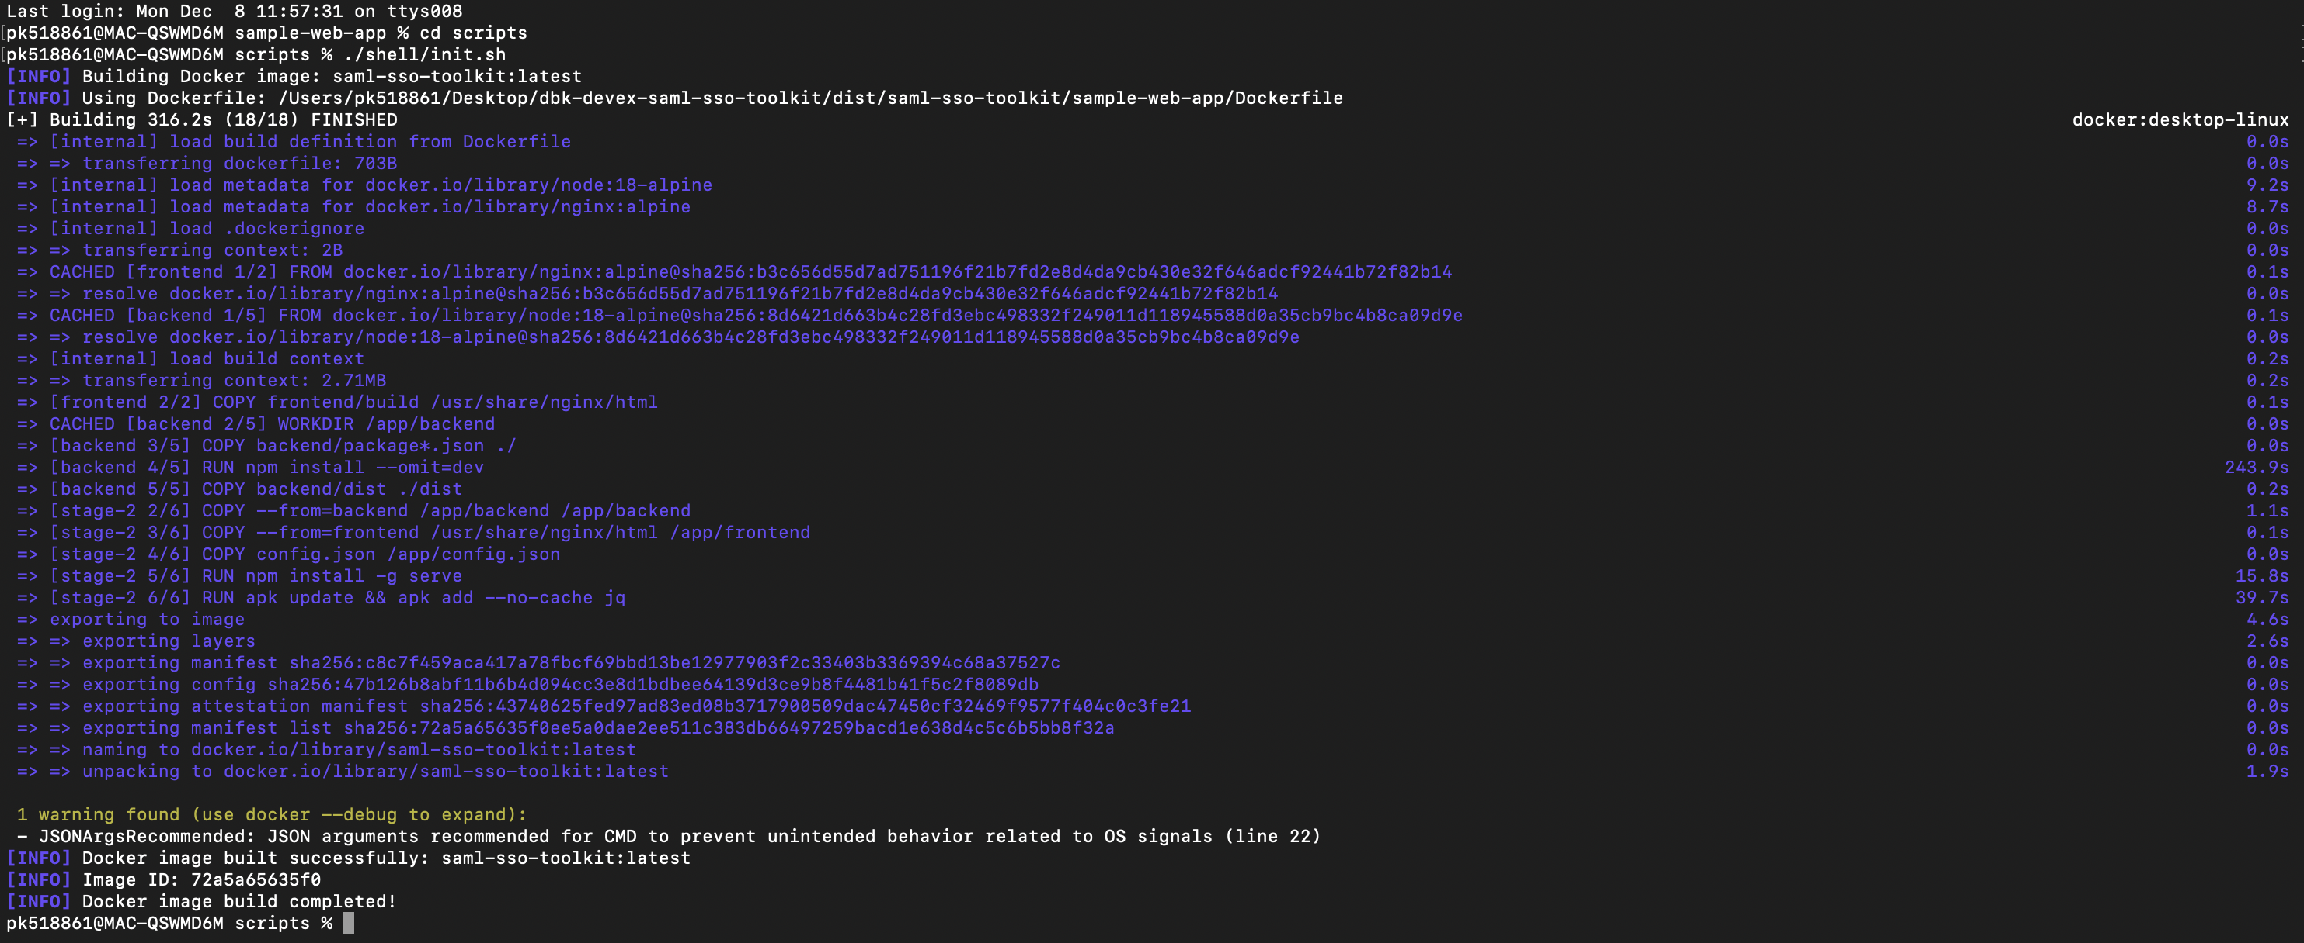

- Run the application container:
./shell/run-web-app.sh

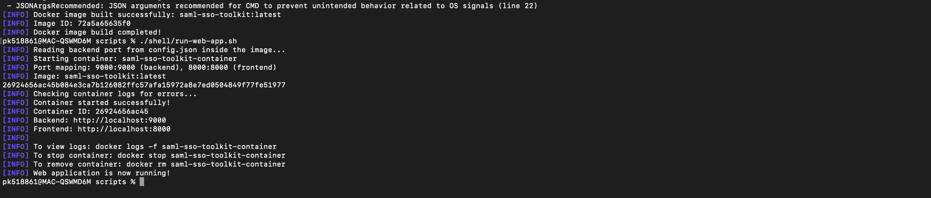
- Verify the health of the backend and frontend applications:
./shell/selftest.sh
Check for success response in the log, as shown below:
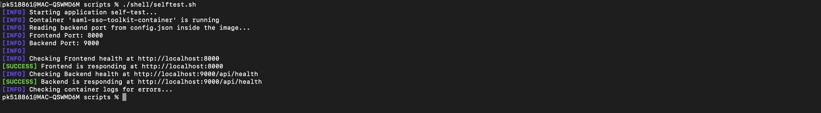
- Open frontend in browser: http://localhost:8000

Note: If the frontend port is modified in step 3, then open
http://localhost:<port>

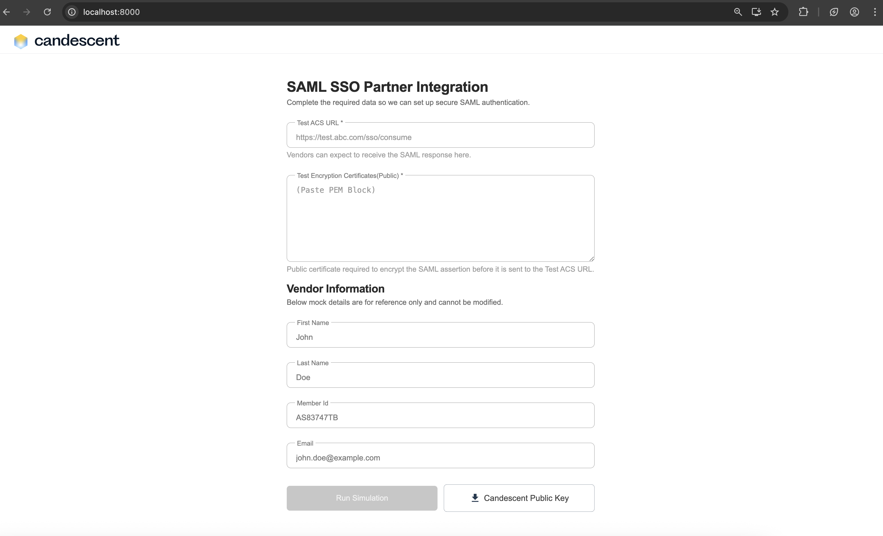

Installation steps for PowerShell environment (Windows)

- Unzip the zip file containing the SAML Toolkit, saml-sso-toolkit.zip, inside any desire folder on the local machine

- Ensure the Docker process is running in the background. If not, start Docker using Docker Desktop or any other mechanism

- Configure Frontend and Backend Ports (Optional):
By default, the frontend application binds to port 8000, and the backend application binds to port 9000. However, if required, these ports can be changed to any other desired values.

Update the port numbers in /sample-web-app/config.json to new values for both frontend and backend and restart the server to apply the updated ports.

- Navigate to the scripts folder and build the Docker image:
cd scripts
./ps/init.ps1
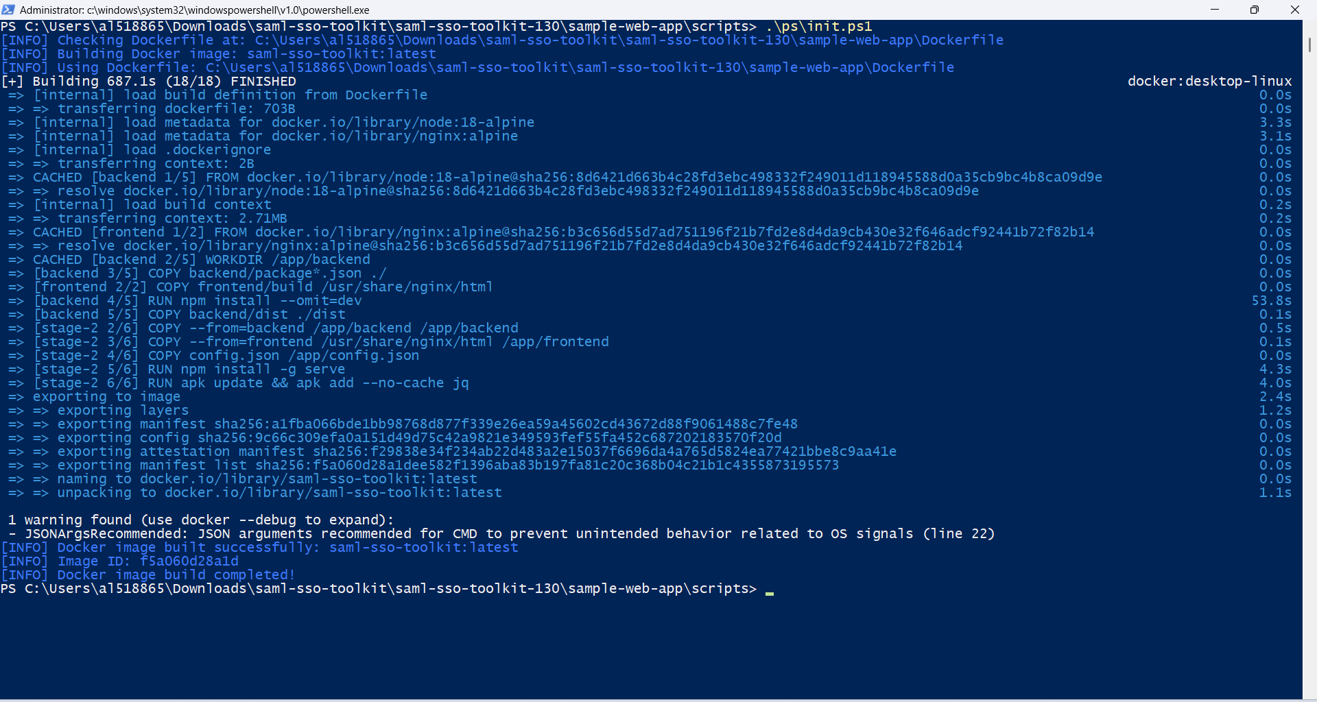
Note: If the above command triggers a security error
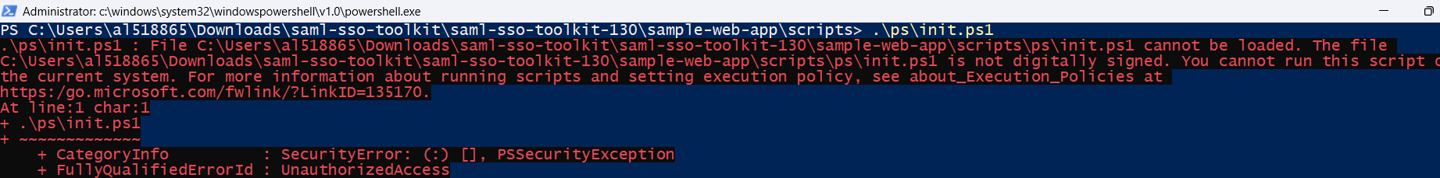
Solution: Bypass the security using the command provided below.

Set-ExecutionPolicy -Scope Process -ExecutionPolicy Bypass
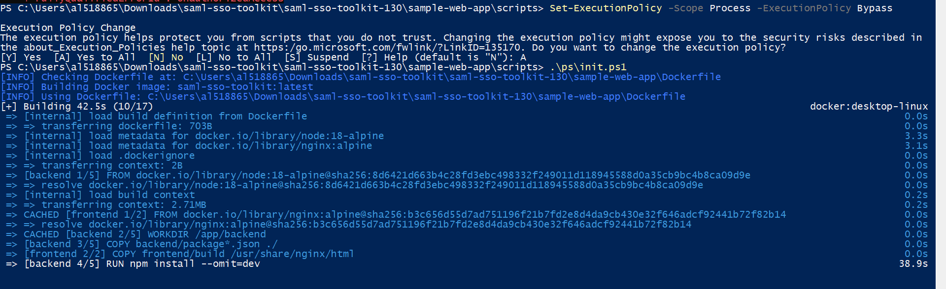

- Run the application container:
./ps/run-web-app.ps1
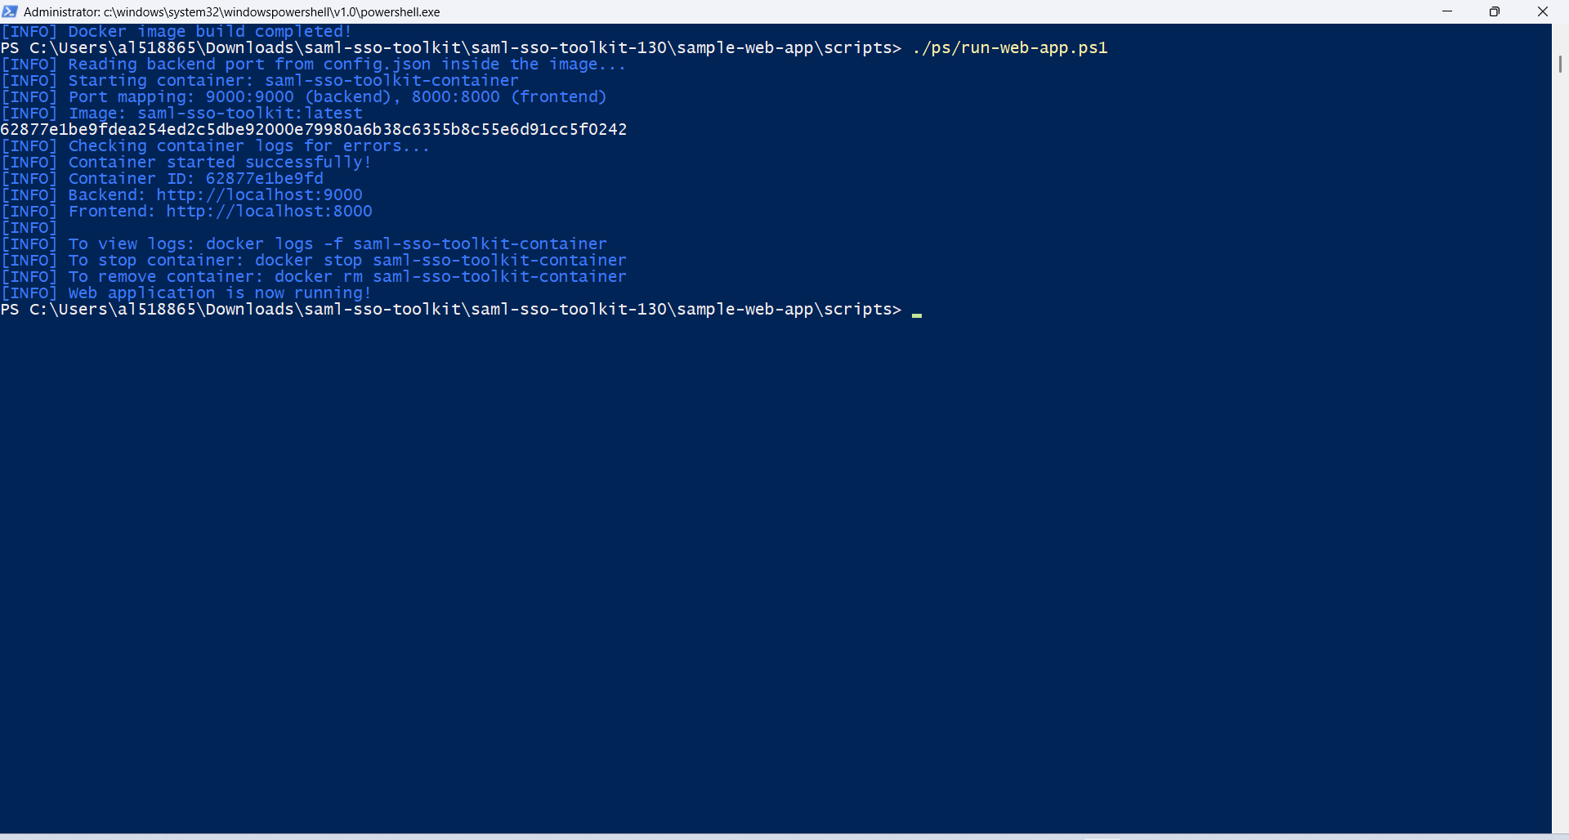

- Verify the health of the backend and frontend applications:
./ps/selftest.ps1

Check for success response in the log, as shown below:

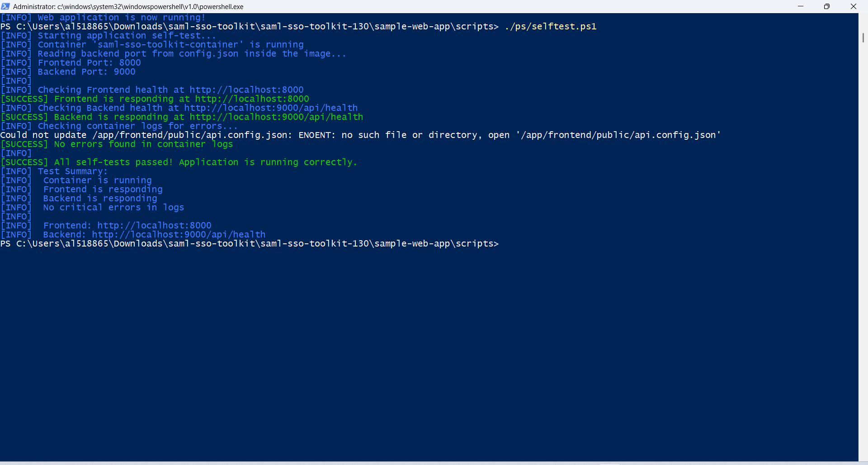
- Open frontend in browser: http://localhost:8000

Note: If the frontend port is modified in step 3, then open
http://localhost:<port>

3.2 Local Machine Native Setup

Prerequisites
Before running the toolkit locally, ensure the following are installed on the local machine:
- Node.js 22
- npm 8+
Note: Docker is not required for local native setup.

Setup Steps
Important: Make sure to setup and start backend server, before installing frontend server.
Backend Setup
- Navigate to backend folder within the unzipped toolkit and install dependencies by running the following commands:
cd sample-web-app/backend
npm install

2. Configure Backend Port (Optional):
By default the frontend application binds to port 8000, and the backend application binds to port 9000. However, if required, these ports can be changed to any other desired values.

Update the port numbers in /sample-web-app/config.json to new values for both frontend and backend and restart the server to apply the updated ports.
3.Start backend server:
npm run start:prod
(the backend server will bind to the default port 9000)

4. Open the health check URL for backend in browser: http://localhost:9000/api/health

Verify the server health, as indicated by status “ok” in the response.
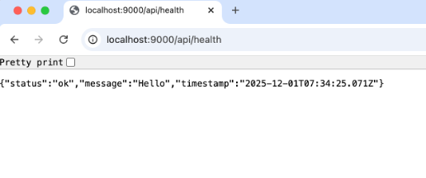
Note: If the frontend port is modified in step 2, then open
http://localhost:<port>/api/health

Frontend Setup
- Navigate to frontend folder and install dependencies:
cd sample-web-app/frontend
npm install
npm install -g serve

2. Configure frontend Port (Optional):
By default, the frontend application binds to port 8000, and the backend application binds to port 9000. However, if required, these ports can be changed to any other desired values.

Update the port numbers in /sample-web-app/config.json to new values for both frontend and backend and restart the server to apply the updated ports.
Note: Both servers must run on different ports to work properly.

3. Start frontend:
serve -s build -l <FE_PORT>

(where <PORT> is the same port as specified in config.json file)

4. Open frontend in browser: http://localhost:8000
(the frontend server will bind to the default port 8000)
Note: If the frontend port is modified in step 2, then open
http://localhost:<port>

4. SAML Toolkit overview
The Toolkit components

4.1 Frontend
- Displays the homepage with the ACS URL, vendor’s public certificate, and mock attributes (non-editable fields).
- Allows downloading the Candescent public key and provides a Run Simulation button on the homepage itself.
- Displays success or error pages based on the response from ACS URL.

4.2 Backend
- Creates SAML assertion in XML format.
- Sign in via candescent private key.
- Encrypts the SAML assertion based on public certificate.

5. Executing the SAML Toolkit
The frontend application gathers the ACS URL and the vendor’s public certificate. It sends these, along with mock attributes (such as first name, last name, email, and member ID), to the backend. The backend generates a SAML assertion, encrypts and signs the assertion, and returns it to the frontend. The frontend then posts the base64 value of SAML response to the ACS URL and displays a success or error page based on the HTTP transmission result.

Step 1 — User Opens the sample Web Application
- Open the URL http://localhost:8000
Note: User can use any configurable port.

Step 2 — Enter Values for following fields
- ACS URL – where the vendor expects the SAML Response.
- Encryption Certificate (Public Certificates) – used by backend to encrypt the SAML assertion.

Also, the page shows User Attributes (Non editable)– basic mock data (firstname, lastname, email).

- Download the Candescent Public Key by clicking the ‘Candescent Public Key’ button.

- Click Run Simulation to trigger a call to the backend IDP endpoint.

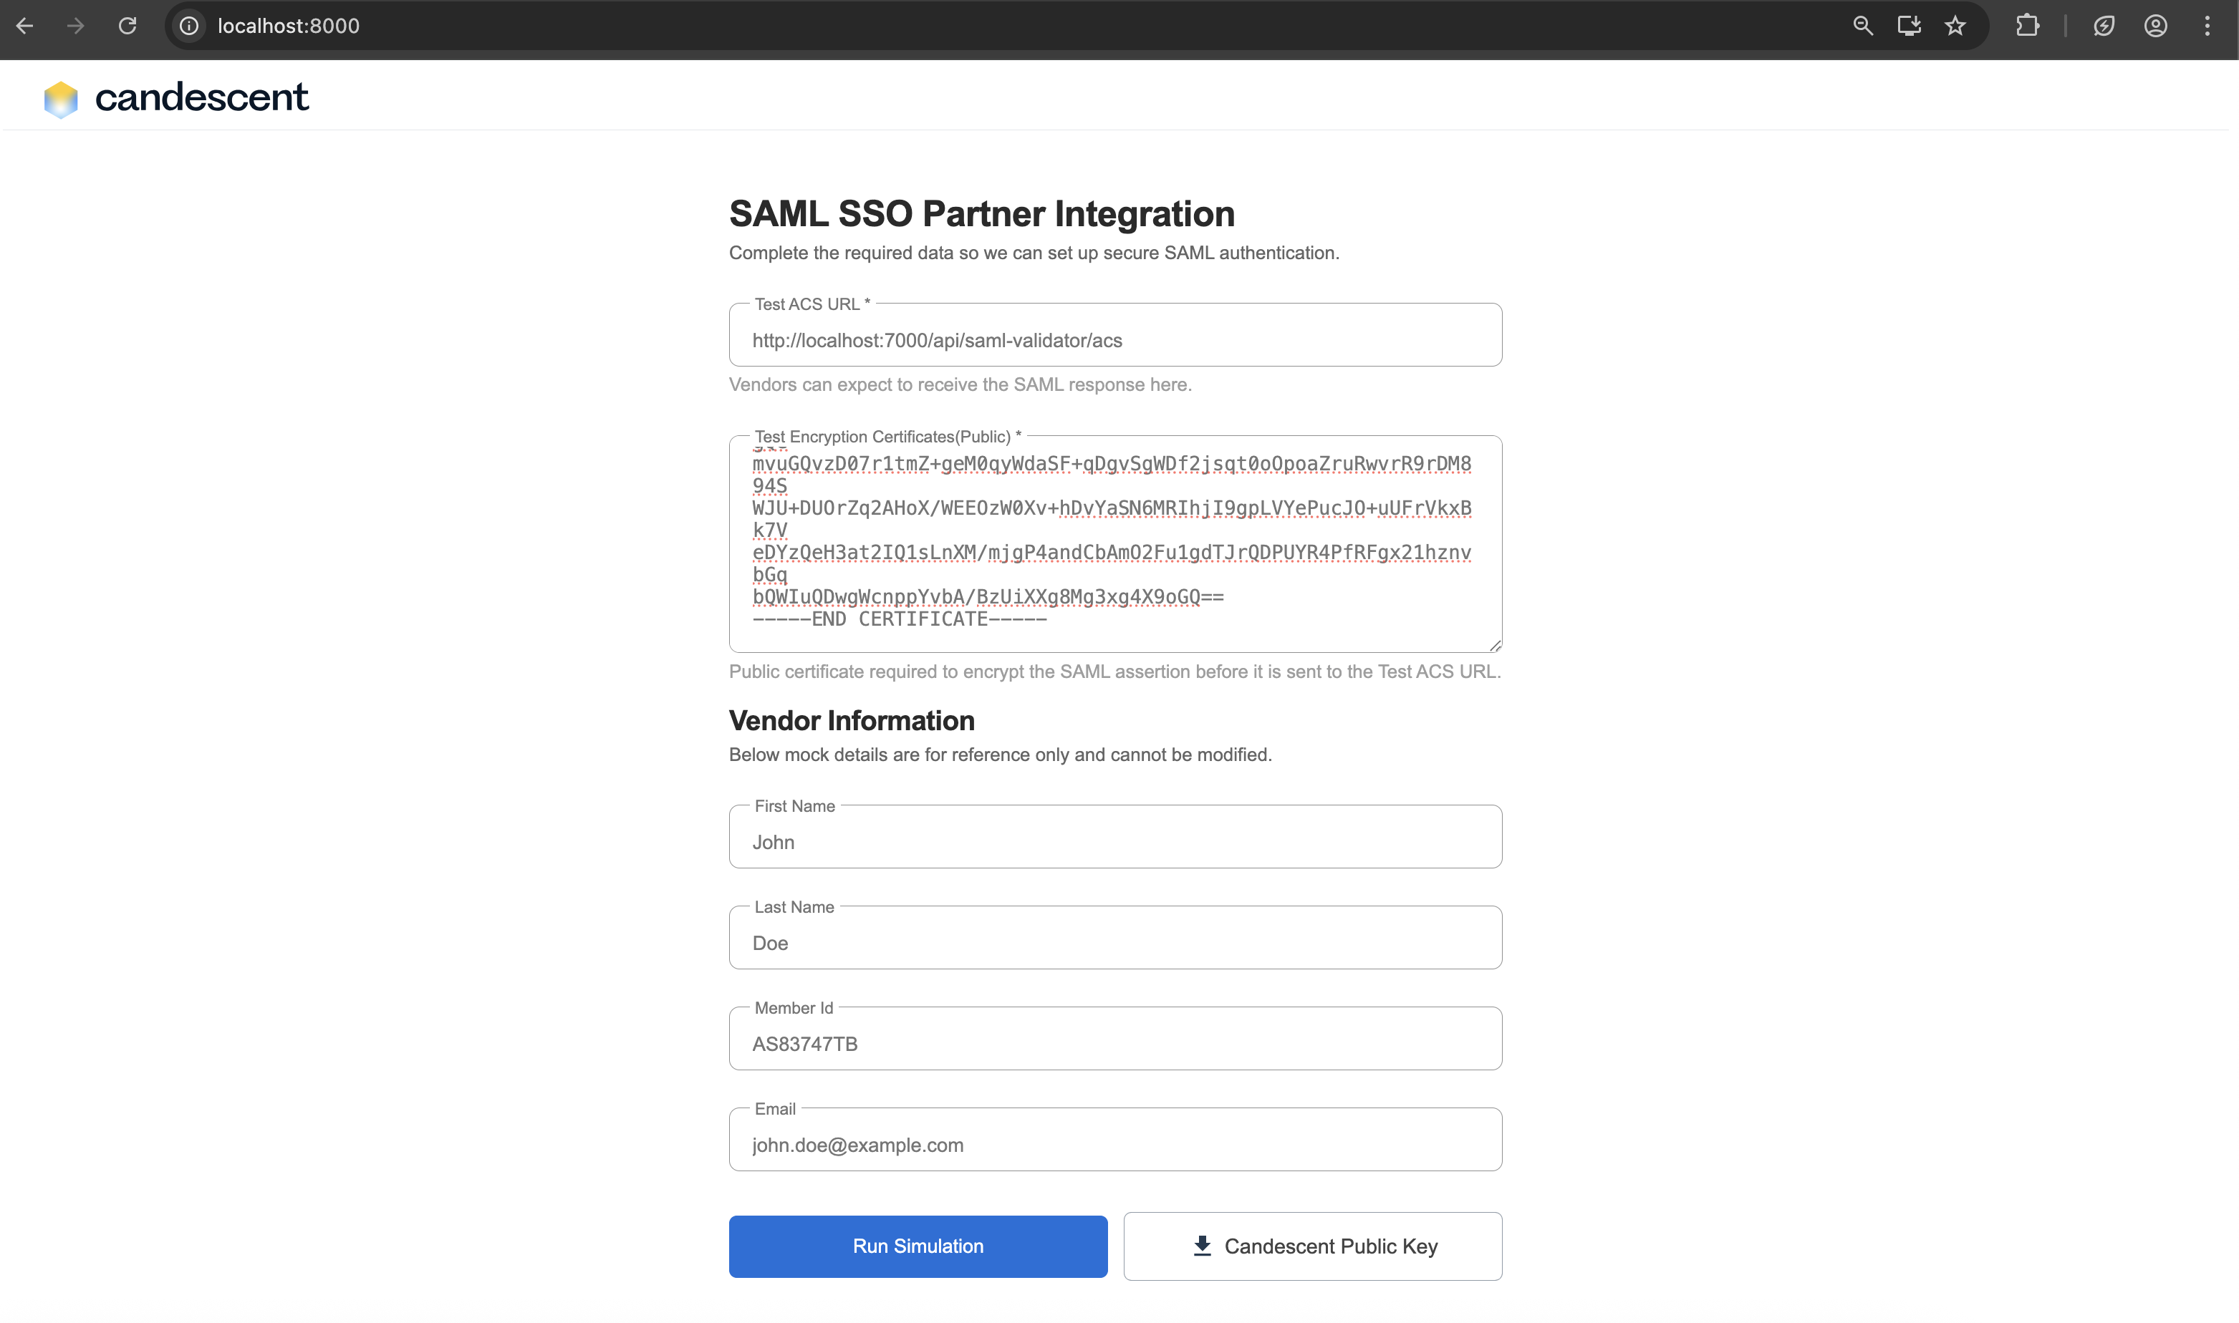

Note:

What the frontend does
- Sends a request containing the above values to the backend.
- Waits for the backend to return the SAML Assertion (valid for 15 mins).

- Displays:
  - Success page (HTTP 200)

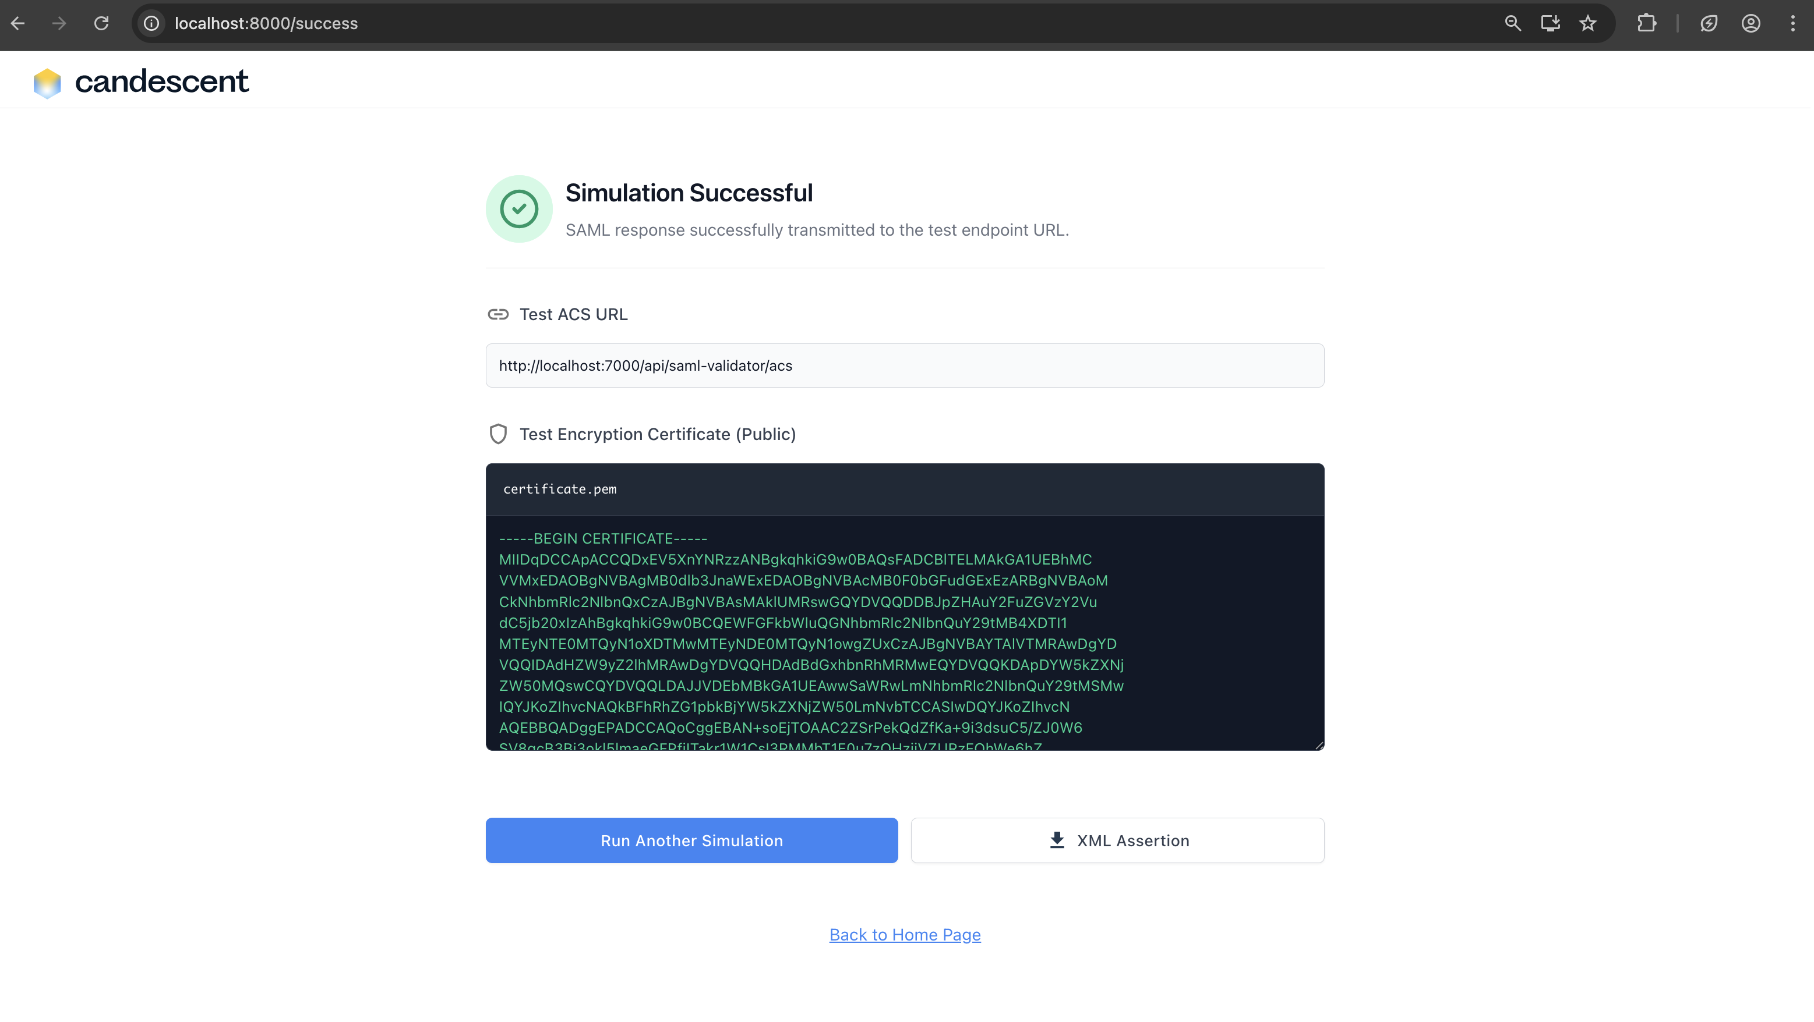
  - Error page (HTTP 4xx, timeout, network failure)
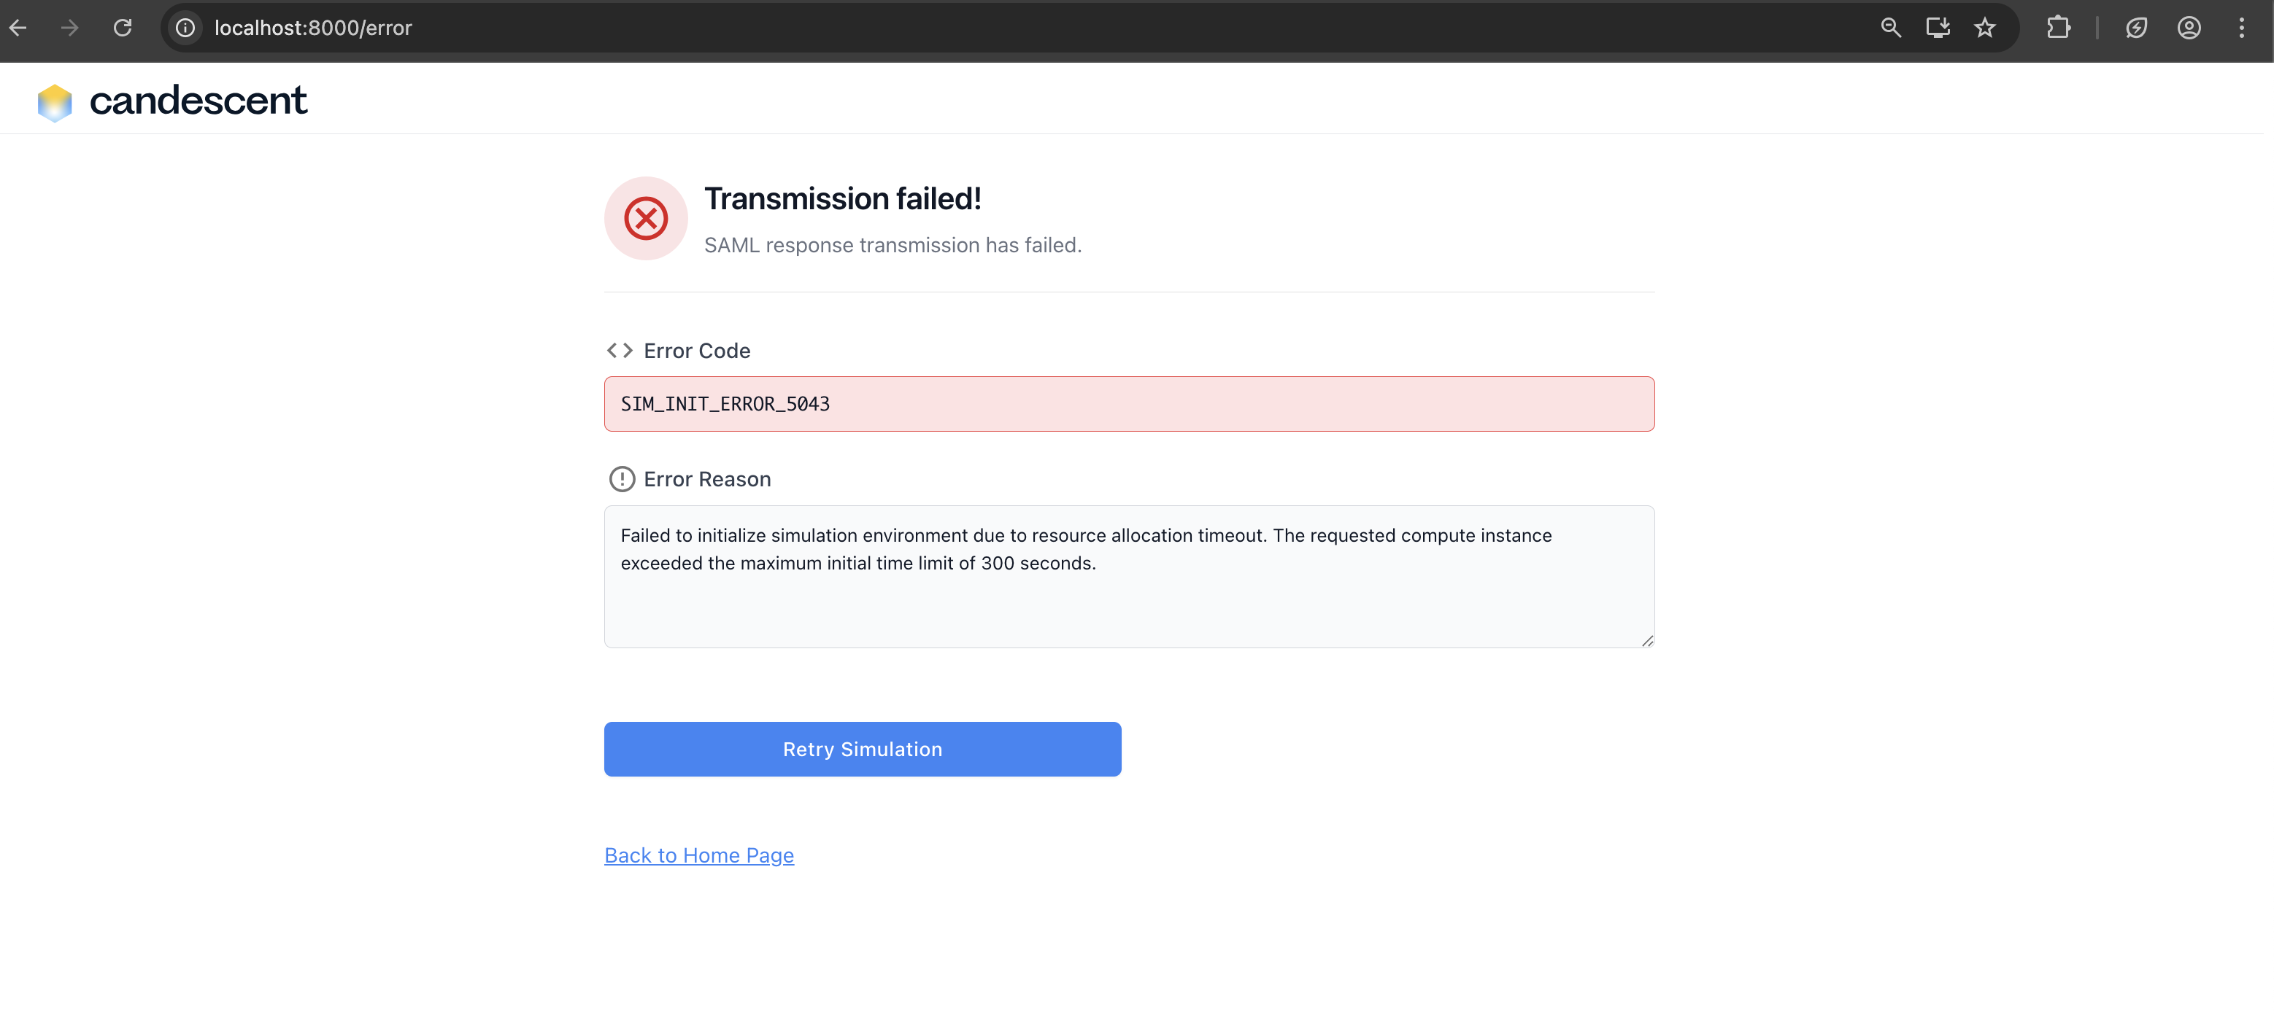
- Allows Retry Simulation or Back to Homepage.

Note:
This backend endpoint simulates the Identity Provider.

What the backend does
- Creates a SAML Assertion in XML format.
- Sign up for the SAML using Candescent’s private key.
- Encrypts the assertion using the vendor’s supplied public certificate (from Step 1).
- Base64 encodes the entire SAML Response.
- Sends Response to ACS URL.

6. SAML Endpoints and Parameters

6.1 SAML login

Purpose
Initiates the SAML authentication simulation flow.

Example Request
Sample Request - {
"acsUrl": "https://vendor.example.com/saml/acs",
"publicCertificate": "-----BEGIN CERTIFICATE----- ",
"attributes": {
"firstName": "John",
"lastName": "Doe",
"memberId": "AS83747TB",
"email": "john.doe@example.com" }}
Sample Response - {
"success": true,
"acsUrl": "https://vendor.example.com/saml/acs",
"publicCertificate": "-----BEGIN CERTIFICATE----- ",
"xml": "<samlp:Response xmlns:samlp=\"urn:oasis:names:tc:SAML:2.0:protocol\" ID=\"response-j508hdyihc\" Version=\"2.0\" IssueInstant=\"2025-11-28T10:55:57.937Z\" Destination=\"https://vendor.example.com/saml/acs\">\n <saml:Issuer xmlns:saml=\"urn:oasis:names:tc:SAML:2.0:assertion\">Candescent</saml:Issuer>\n <saml:Assertion xmlns:saml=\"urn:oasis:names:tc:SAML:2.0:assertion\" ID=\"assertion-isanqrinvio\" IssueInstant=\"2025-11-28T10:55:57.937Z\" Version=\"2.0\">\n <saml:Issuer>Candescent</saml:Issuer>\n <saml:Subject>\n <saml:NameID>AS83747TB</saml:NameID>\n <saml:SubjectConfirmation Method=\"urn:oasis:names:tc:SAML:2.0:cm:bearer\">\n <saml:SubjectConfirmationData NotOnOrAfter=\"2025-11-28T11:00:57.937Z\" Recipient=\"https://vendor.example.com/saml/acs\"/>\n </saml:SubjectConfirmation>\n </saml:Subject>\n <saml:Conditions NotOnOrAfter=\"2025-11-28T11:00:57.937Z\">\n <saml:AudienceRestriction>\n <saml:Audience>john.doe@example.com</saml:Audience>\n </saml:AudienceRestriction>\n </saml:Conditions>\n <saml:AttributeStatement>\n <saml:Attribute Name=\"firstName\">\n <saml:AttributeValue>John</saml:AttributeValue>\n </saml:Attribute>\n <saml:Attribute Name=\"lastName\">\n <saml:AttributeValue>Doe</saml:AttributeValue>\n </saml:Attribute>\n <saml:Attribute Name=\"email\">\n <saml:AttributeValue>john.doe@example.com</saml:AttributeValue>\n </saml:Attribute>\n <saml:Attribute Name=\"memberId\">\n <saml:AttributeValue>AS83747TB</saml:AttributeValue>\n </saml:Attribute>\n </saml:AttributeStatement>\n </saml:Assertion>\n</samlp:Response>"
}

7. Validator and Publisher

Step 1:
On the Simulation Successful screen, a link to the SAML Validator will be displayed in the top right corner. Click on the SAML Validator link.
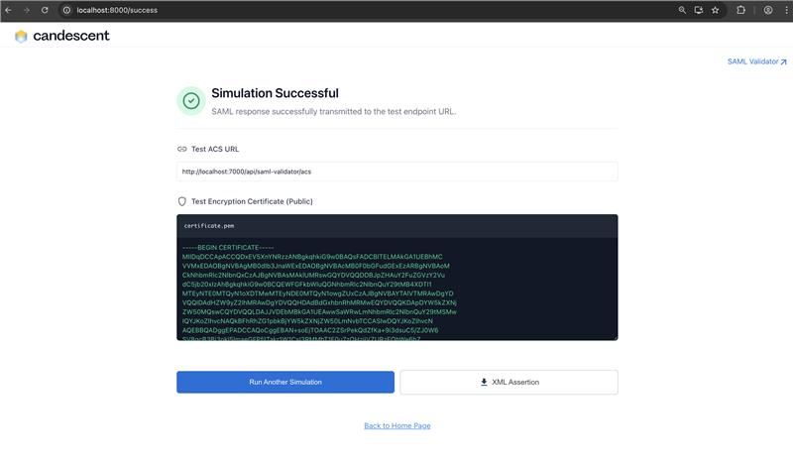

Step 2:
The validator page will open. Click the Run Validator button.
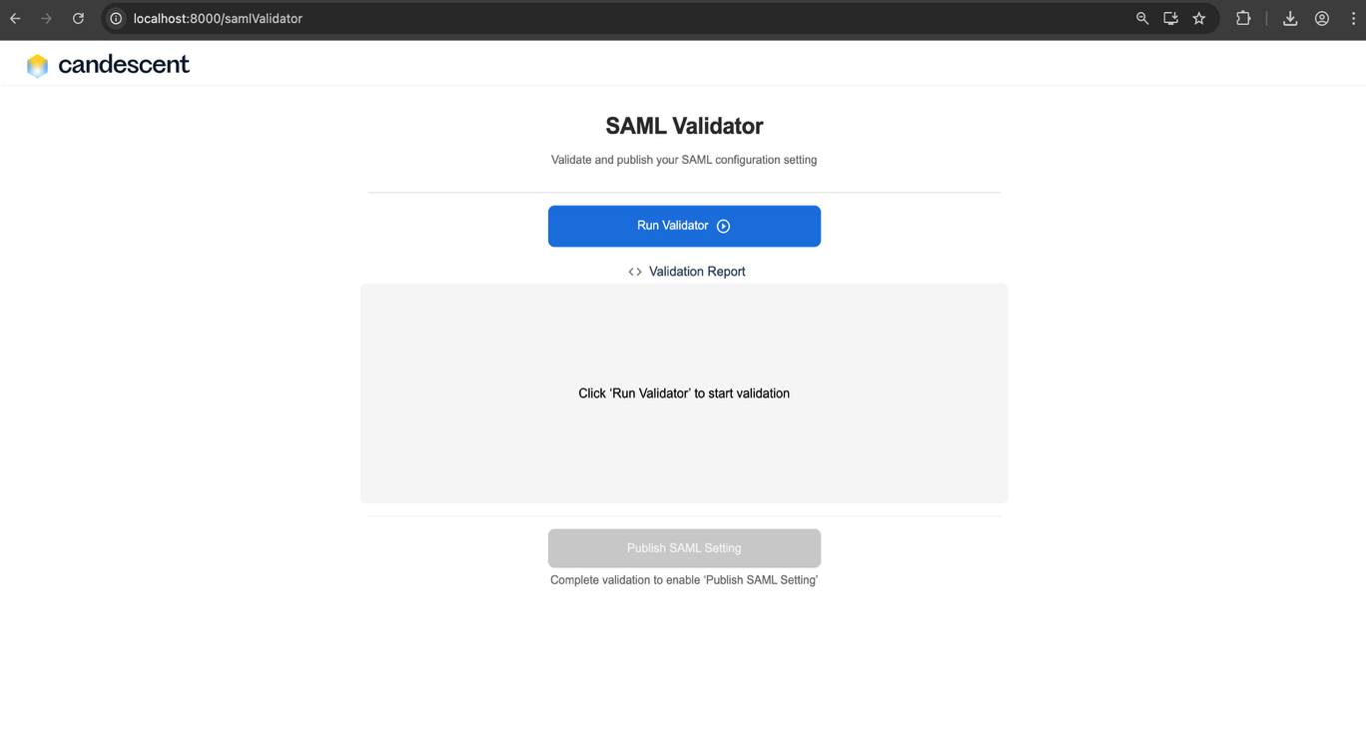

Step 3:
All the test cases will begin executing, and the corresponding validation reports will be displayed.
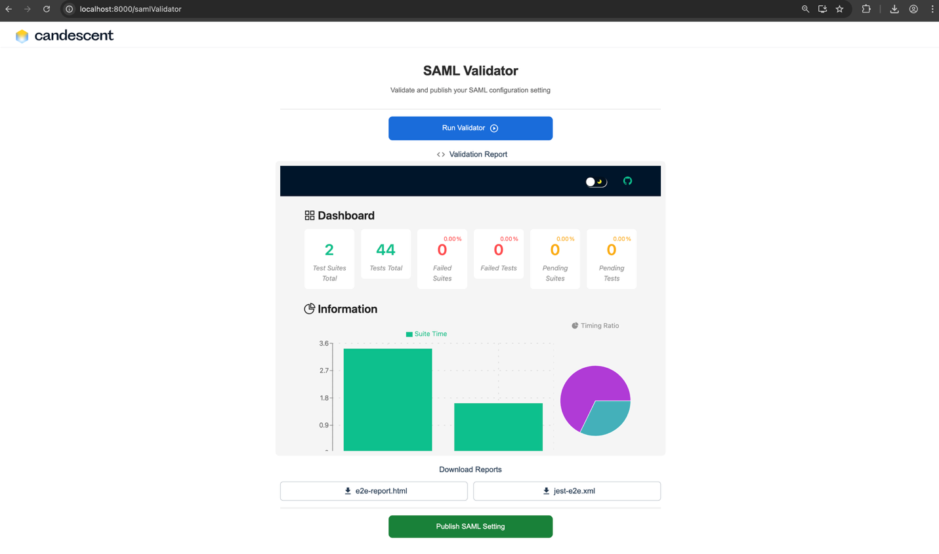

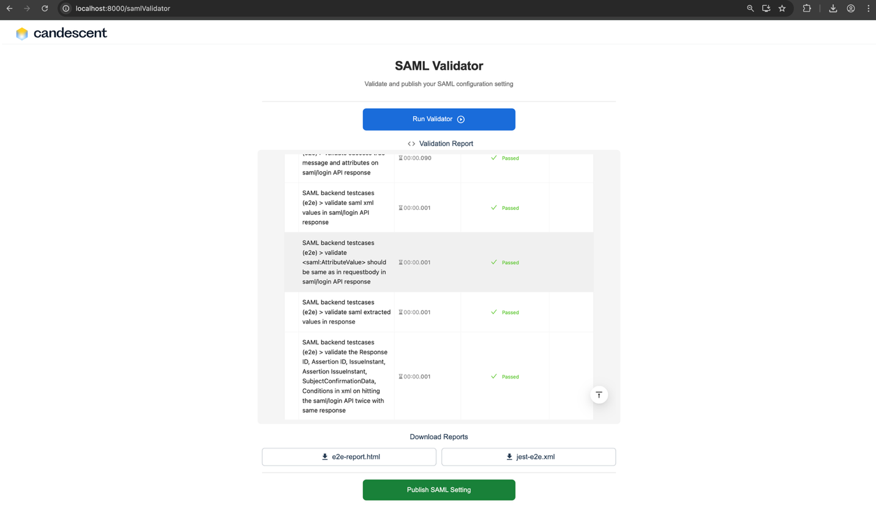

Step 4:
After the test case execution is complete, two additional downloadable test reports will appear:
- e2e-report.html
Click on e2e-report.html button to download it. After downloading, open the html file, to see the report as below:
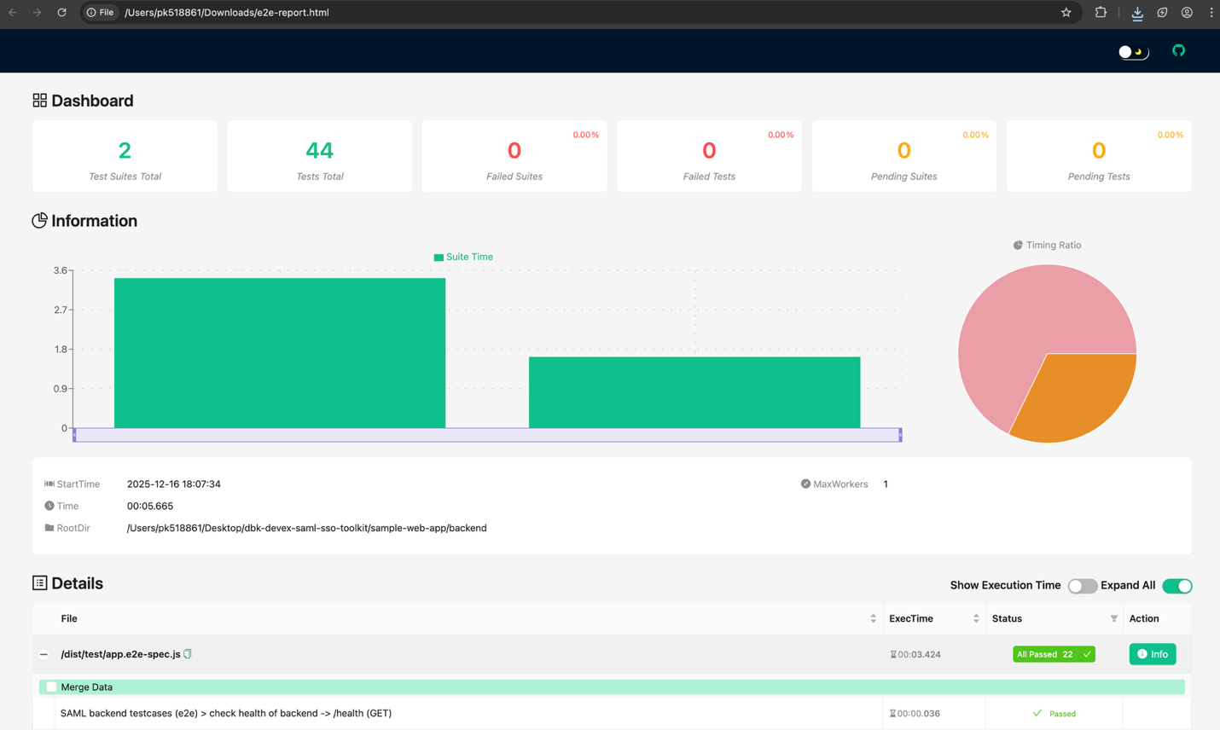

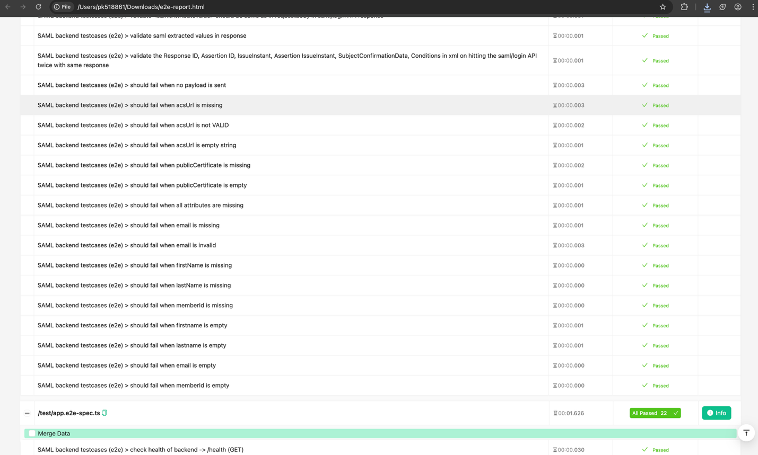

B. jest-e2e.xml
Click on jest-e2e.xml button to download it. After downloading, open the xml file, to see the report as below:
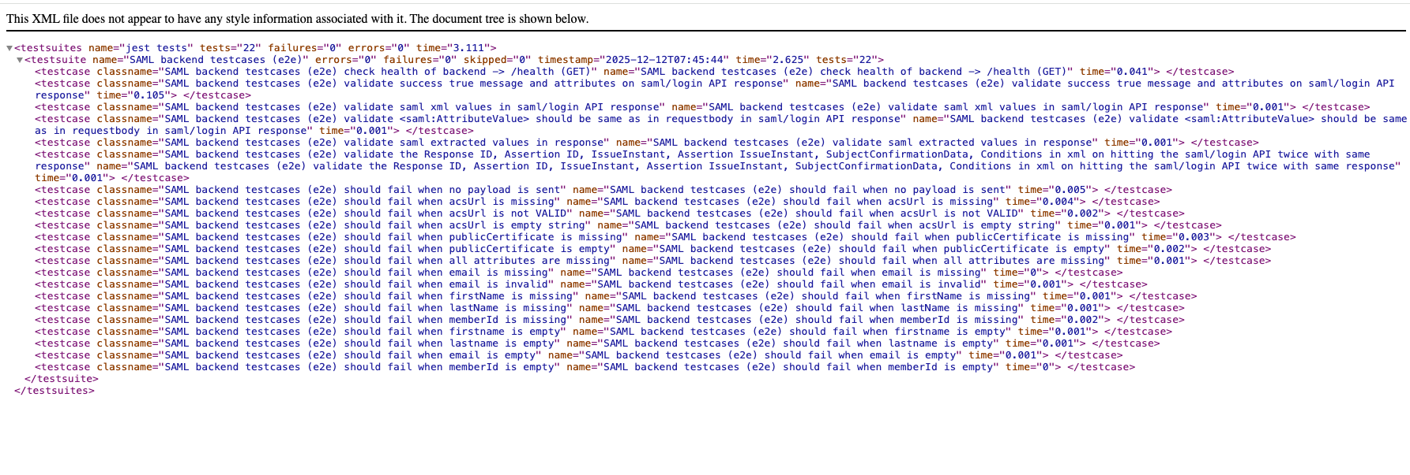

Step 5:
The Publish SAML Setting button will be enabled. Click on the Publish SAML Setting button, a file named samlConfig.json will be downloaded.

Inside samlConfig.json file, the following details will be present:
- frontendPort
- backendPort
- acsUrl
